Circle the affirmative pictures and mark the negatives with a cross. Color the affirmative pictures.
She can dance. She can’t cut.
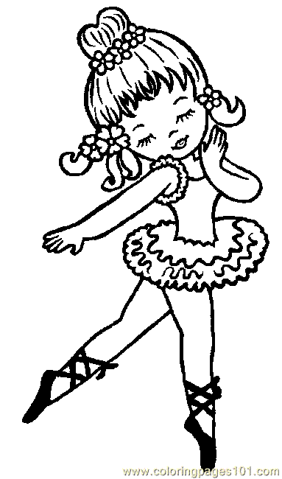 | 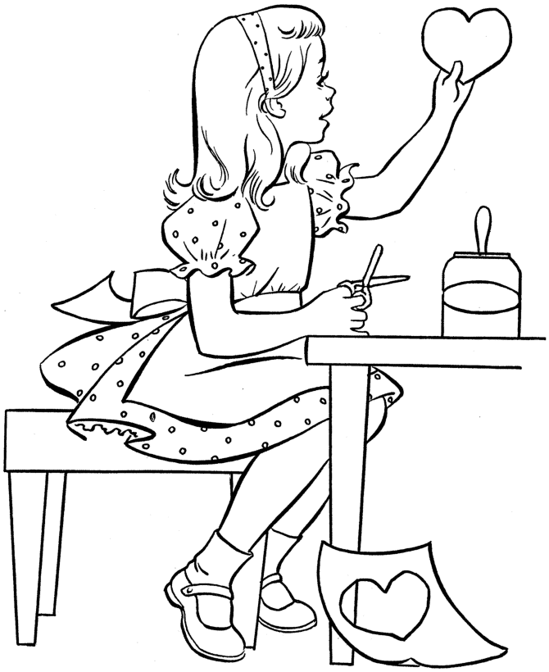
He can’t swim. He can ride a motorcycle.
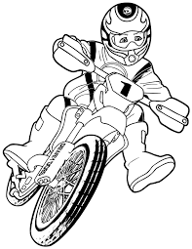 | 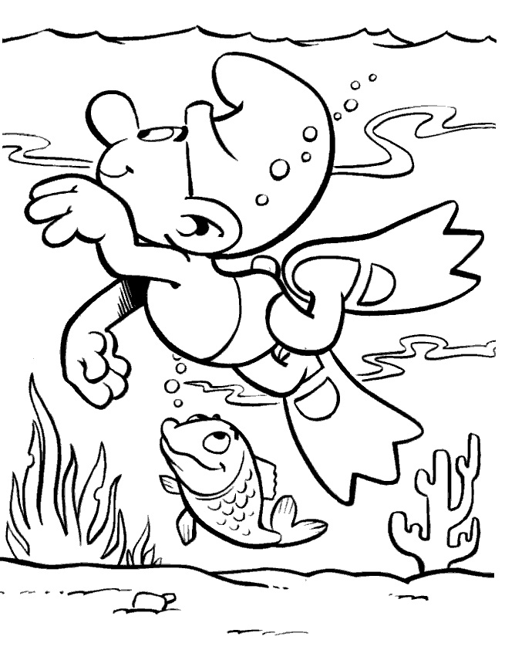
They can play soccer. They can’t swim.
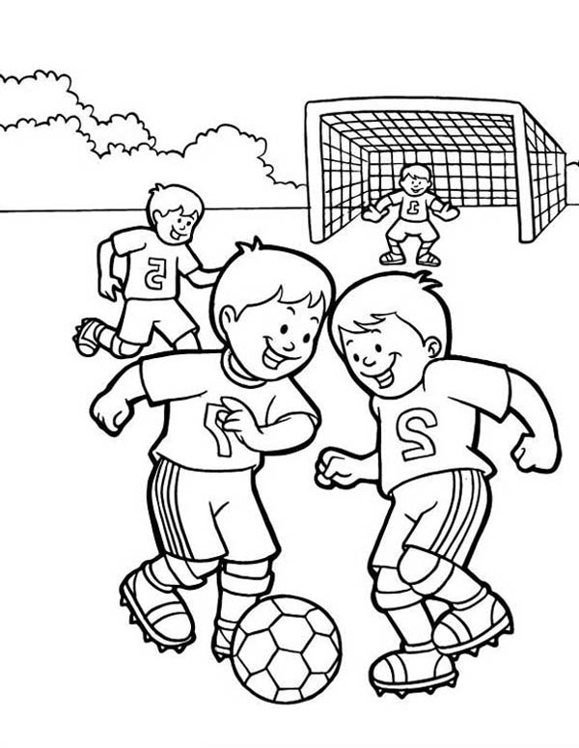 | 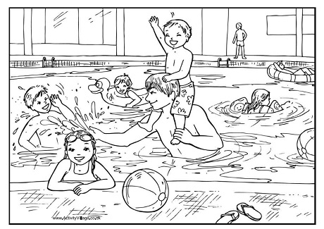
They can study. They can’t jump.
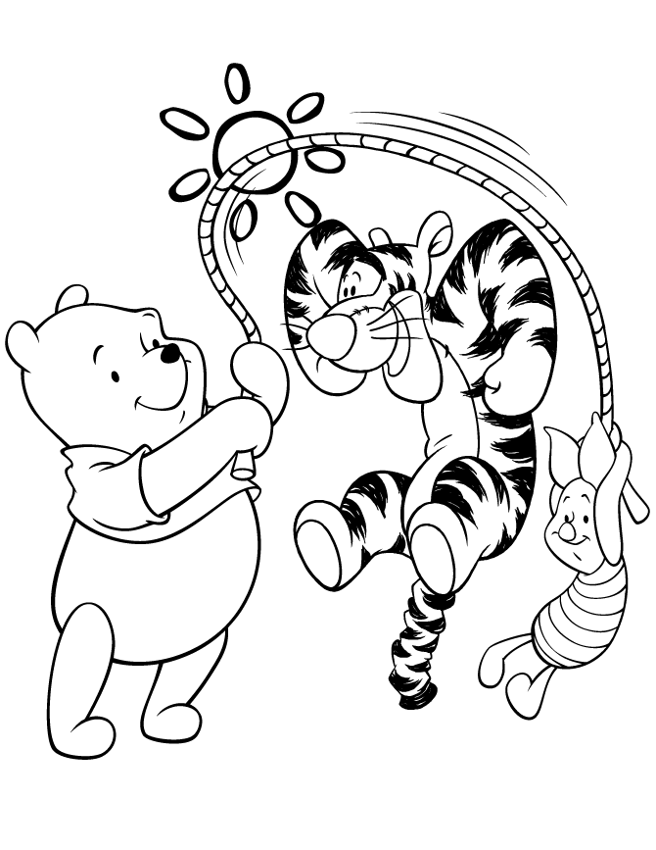 | 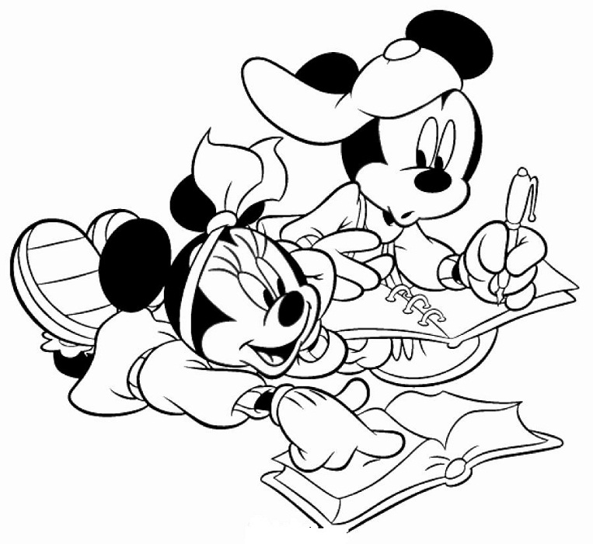
He can’t sing. She can sing.
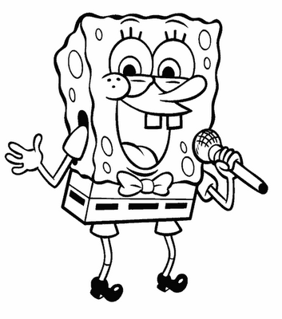 | 