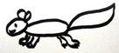
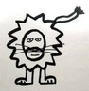
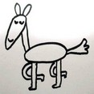
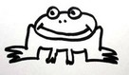
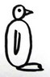
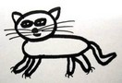
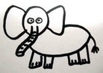
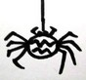
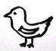
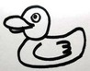
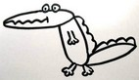
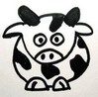
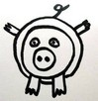
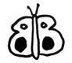
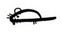
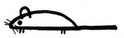
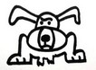
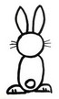
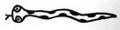
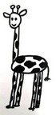
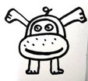
Animal Riddles
Can you find out what I am?
I have four legs.
I live in Africa.
I am big and grey.
I live in the river.
I am beautiful.
I have six legs.
I can fly.
I eat honey.
I am small.
I can be scary.
I have eight legs.
I spin a web.
I am small.
I have feathers.
I lay eggs.
I can sing and fly.
I oink.
I give you bacon.
I like mud and dirt.
I am pink.

I am small and brown.
I eat nuts.
I can climb trees.
I have a nice tail.

I live on the farm.
I have horns.
I moo.
I give milk.
I live in the house.
I eat everything.
I am small and grey.
Cats eat me.
I can swim.
I can’t fly.
I eat fish.
I am a bird.
I have a mane.
I whinny.
You can ride me.
I live in a barn.
I live in the city.
I have a long tail.
I eat rubbish.
People don’ like me.
I am a pet.
I like mice.
I have nine lives.
I purr and meow.
I am brown.
I have a mane.
I like to eat zebras.
I roar.
I live in Africa.
I am yellow and brown.
I eat leaves.
I have a long neck.
I eat vegetables.
I can run fast.
I can be a pet.
I have long ears.
I eat insects.
I live in the pond.
I hop.
I am green.
I hiss.
I can be poisonous.
I am long.
I have a forked tongue.
I have four legs.
You can ride me.
I have tusks.
I have a long nose.
I can swim and dive.
I have two legs.
I have wings.
I quack.
I eat other animals.
I have a big mouth.
I am green.
I live in the water.
I have four legs.
I am a pet.
I hate cats.
I bark.


I have four legs.
I live in Africa.
I am big and grey.
I live in the river.HIPPO
I am beautiful.
I have six legs.
I can fly.
I eat honey. BUTTERFLY
I am small.
I can be scary.
I have eight legs.
I spin a web.SPIDER
I am small.
I have feathers.
I lay eggs.
I can sing and fly.BIRD
I oink.
I give you bacon.
I like mud and dirt.
I am pink.PIG

I am small and brown.
I eat nuts.
I can climb trees.
I have a nice tail. SQUIRREL

I live on the farm.
I have horns.
I moo.
I give milk.COW
I live in the house.
I eat everything.
I am small and grey.
Cats eat me.MOUSE
I can swim.
I can’t fly.
I eat fish.
I am a bird. PENGUIN
I have a mane.
I whinny.
You can ride me.
I live in a barn.HORSE
I live in the city.
I have a long tail.
I eat rubbish.
People don’ like me.RAT
I am a pet.
I like mice.
I have nine lives.
I purr and meow.CAT
I am brown.
I have a mane.
I like to eat zebras.
I roar.LION
I live in Africa.
I am yellow and brown.
I eat leaves.
I have a long neck. GIRAFFE
I eat vegetables.
I can run fast.
I can be a pet.
I have long ears.RABBIT
I eat insects.
I live in the pond.
I hop.
I am green.FROG
I hiss.
I can be poisonous.
I am long.
I have a forked tongue. SNAKE
I have four legs.
You can ride me.
I have tusks.
I have a long nose. ELEPHANT
I can swim and dive.
I have two legs.
I have wings.
I quack.DUCK
I eat other animals.
I have a big mouth.
I am green.
I live in the water. CROCODILE
I have four legs.
I am a pet.
I hate cats.
I bark.DOG
Team 1
Team 3
Team 2
Don’t show this to other teams!
Don’t show this to other teams!
Don’t show this to other teams!

